Instruction Manual
Battery Crimping Tool 902-541

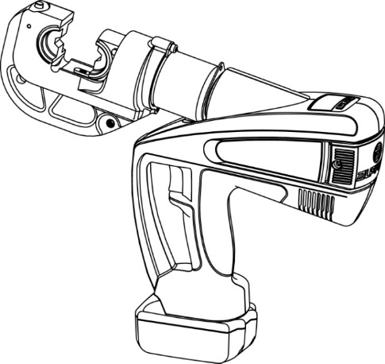

Due to continuing improvements, actual product may differ
slightly from the product described herein.

Read this material before using this product.
Failure to do so can result in serious injury.
SAVE THIS MANUAL

LIMITED 1 YEAR WARRANTY
We make every effort to assure that our products meet high quality and durability standards, and warrant to the original purchaser that this product is free from defects in materials and workmanship for the period of one year from the date of purchase (90 days if used as rental equipment). This warranty does not apply to damage due directly or indirectly, to misuse, abuse, negligence or accidents, repairs or alterations outside our facilities, normal wear and tear, or to lack of maintenance. We shall in no event be liable for death, injuries to persons or property, or for incidental, contingent, special or consequential damages arising from the use of our product. Some states do not allow the exclusion or limitation of incidental or consequential damages, so the above limitation of exclusion may not apply to you. THIS WARRANTY IS EXPRESSLY IN LIEU OF ALL OTHER WARRANTIES, EXPRESS OR IMPLIED, INCLUDING THE WARRANTIES OF MERCHANTABILITY AND FITNESS.

To take advantage of this warranty, the product or part must be returned to us with transportation charges prepaid. Proof of purchase date and an explanation of the complaint must accompany the merchandise. If our inspection verifies the defect, we will either repair or replace the product at our election or we may elect to refund the purchase price if we cannot readily and quickly provide you with a replacement. We will return repaired products at our expense, but if we determine there is no defect, or that the defect resulted from causes not within the scope of our warranty, then you must bear the cost of returning the product.

The warranty gives you specific legal rights and you may also have other rights which vary from state to state.

TROUBLESHOOTING

FAULT | ANALYSIS | SOLUTION
- Tool  is inoperative | - Dirt, contaminants, etc in ram area of tool.  - The battery is dead  - Tool components worn or damaged. | - Clean hydraulic system  - Charge the battery  - Return tool to manufacturer or distributor
- No power during operation or not up to the rated power | - No oil  - Dirt, contaminants inside of oil bag.  - Inner leakage | - Fill oil  - Return tool to manufacturer or distributor  - Return tool to manufacturer or distributor
- Crimp not tight | - Not up to rated power  - Error selecting the correct crimping die | - Refer the B  - Return tool to manufacturer or distributor
- Creates too many scrap crimps | - Error selecting the correct crimping die | - Change reasonable crimping die
- Leakage on the crimping head o plunger | - Worn on the sealing kits | - Return tool to manufacturer or  distributor
- Running of the motor but no power output | - No oil in the oil bag  - Air is in the hydraulic system  - Cold oil | - Fill or change the oil  - Return tool to manufacturer or distributor  - Use the tool between -20℃-40℃

SAVE THIS MANUAL
Keep this manual for the safety warnings and precautions, assembly, operating, inspection,
maintenance and cleaning procedures. Write the month and year of purchase. Keep this
manual and the receipt in a safe and dry place for future reference.

IMPORTANT SAFETY INFORMATION
In this manual, on the labeling, and all other information
provided with this product:

This is the safety alert symbol. It is used to alert you to potential
personal injury hazards. Obey all safety messages that follow this
symbol to avoid possible injury or death.

DANGER indicates a hazardous situation which,
if not avoided, will result in death or serious injury.

WARNING indicates a hazardous situation which,
if not avoided, could result in death or serious injury.

CAUTION, used with the safety alert symbol,
indicates a hazardous situation which, if not avoided,
could result in minor or moderate injury.

GENERAL SAFETY RULES
TO WORK IN SAFE CONDITIONS WITH THIS TOOLING, IT IS IMPERATIVE TO READ CAREFULLY THE DIRECTIONS FOR USE AND TO FOLLOW THE INSTRUCTIONS IT CONTAINS. IF YOU DO NOT RESPECT THE INFORMATION WRITTEN IN THAT INSTRUCTION MANUAL THE WARRANTY WILL BE CANCELED.

1. Work area safety
  - Keep work area clean and clear. Cluttered or dark areas invite accidents.
  - This tool is not insulated; please do not use it on live conductor.
  - Please do not use or store the tool under high temperature, or one filled with corrosive fluid. Pay attention to the sealing kits becoming old and leaky.
  - Keep children and bystanders away while operating the Battery powered crimping tool. Distractions will cause you to lose control.
  - Do not use or charge the tool around flammable, explosive environment

2. Electrical safety
  - Make sure the plug matches with the outlet. Never try any changes on the plug.
  - Do not put tool, battery and charger into rainy or humid surroundings, it is easy to trigger an electric shock accident if any water goes into the electric system of the tool.
  - Do not use electric wire to carry, pull, or to pull out the plug and do not connect the “-”and “+”, the damaged or twisted wire may cause an electric shock accident.
  - If the charger was strongly impacted, or dropped or any other damage happened, please do not try to repair it by yourself, send it back to the authorized service center as soon as possible. The damaged charger may cause an electric shock accident.
- If the tool not used for a long time, please make sure the piston stays in its starting position, clean up the tool and rub rustproof oil both to the tool piston and accessories. Take out the battery and put it into a box and store the tool in a dry surrounding. As following:
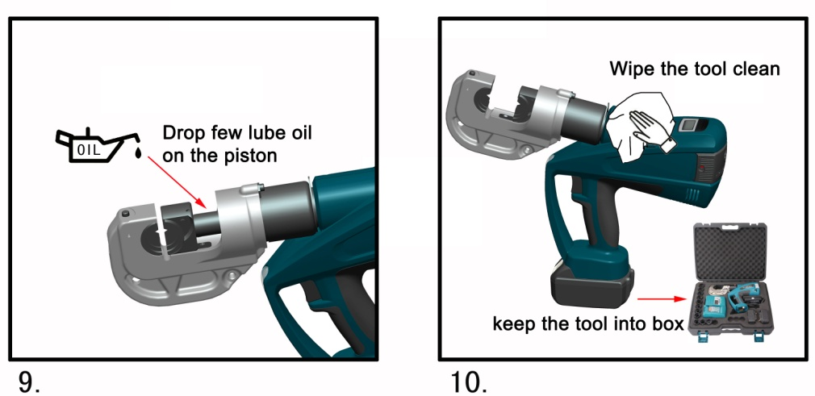

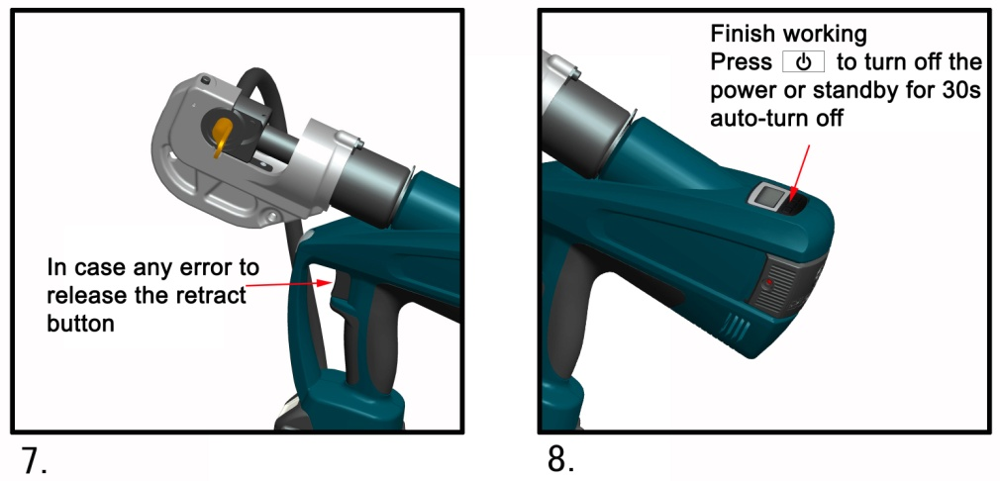

MAINTENANCE AND SERVICING
Damaged equipment may cause serious personal injury. Do not use damaged equipment. If abnormal noise or vibration occurs, have the problem corrected before further use.

- Before each use, inspect the general condition of the tool. Check for loose screws, misalignment or binding of moving parts, cracked or broken parts, or any other condition that may affect its safe operation.
- After using, clean external surfaces of the tool with a clean, moist rag, and rub rust preventing oil on the metal surface of the tool and the dies to avoid rust. Store the tool in the dry environment.
- Service to the tool should only be done by a qualified Service Technician.
- In order to prolong the life of the tool please change the oil each year. Make sure the oil is filtered by 120 mesh net or over 30µm strainer. Meantime avoid getting dust into the oil cup.
- After a long time using, the sealing kits will be damaged, if there is leakage please contact with the manufacturer and/or the distributor to change the sealing kits.

  - The best temperature for charging is between 10℃-40℃. Make sure the air hole of the battery and charger are uncovered during charging.
  - Please cut off the power of the charger each time to reduce the hazard from children or persons who are not expert with the tool.
  - Do not wait until the battery runs out for recharging, the recharging will cause the battery to not work anymore. Please keep the battery out of the tool to avoid the power discharge.
  - Please do not burn the battery or make it being short-circuited, it may cause explosion.
  - Do not use the spent battery otherwise it may cause the electric shock.
  - Do not disassemble the battery and charger. If any problem please contact with manufacturer or its agent.

3. Personal safety
  - Stay alert, watch what you are doing and use common sense when operating the tool. Do not use the tool while you are tired or still under the influence of drugs, alcohol or medication. A moment of inattention may result in series personal injury.
  - Use safety equipment. Always use safety equipment such as mask, helmet, safety cap, insulating shoes and etc to reduce the risk of personal injury.
    - Dress properly. Do not wear loose clothing or jewelry. Keep your hair, clothing and gloves away from moving parts. Loose clothes, jewelry or long hair can be caught in moving parts.
    - Maintain power tools. Check for misalignment or binding of moving parts, breakage of parts and any other condition that may affect the tool operation. If damaged, have the tool repaired before use. Many accidents are caused by poorly maintained power tools.
    - Please use the tool properly, the tool with correct power will do the job better and safer at the rate for which it was designed.
    - Do not put your fingers into the head of the tool during operating. Your fingers could be pinched very severely.

4. Service
Have your Battery Crimping Tool serviced by a qualified service technician using only identical replacement parts. This will ensure that the safety of the Battery Crimping Tool Kit is maintained.

SPECIFIC SAFETY RULES
- Maintain labels and nameplates on the tool which carry important safety information. If unreadable or missing, contact the agent to replace.
- This product is not a toy, keep it out of reach of children.
- Do not put your fingers into the head of the tool during operating. Your fingers could be pinched very severely.
- Make sure the head was locked firmly during operation.
- Do not use the tool without dies
- Do not crimp on live cables or conductors
- Do only crimp copper or aluminum conducting material
- Do not knock any parts of the tool, otherwise it will cause injury.
- Do not operate at will, it will damage the MCU and electric system
- The design of the limit screw on the head is for preventing the head from dropping or popping.
- Make sure the head was locked firmly during operation.
- Do not use this tool for continuous use. After 30 to 40 cycles, allow the tool to cool for 15 minutes.
- Do not secure this tool in a vise. This tool is designed for hand-held operation.
- The built-in safety valve goes through strict pressure test before service; please do not adjust the pressure. It should be done only by professional technicians. If the pressure is not enough, please return the tools to the service center. The tool only can be reused after checking and testing by trained person.
- The warnings, precautions, and instructions discussed in this instruction manual cannot cover all possible conditions and situations that may occur. It must be
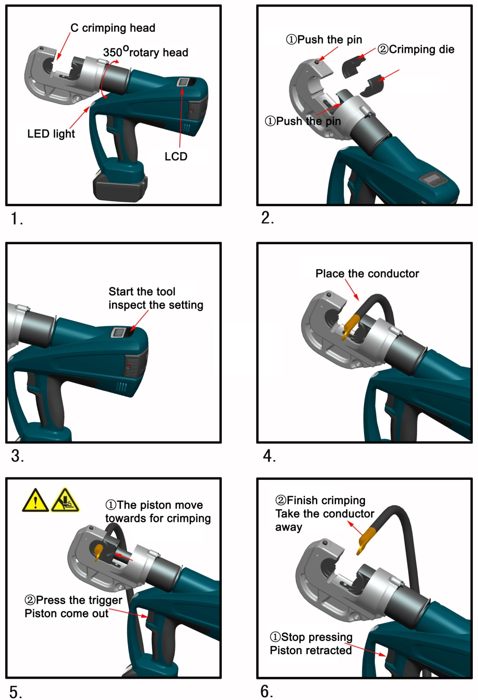

Make sure that all the parts are clean without any oil, dust, especially on the handle and control parts, to avoid dropping of the tool during operation.
First press the for 3 s to turn on the power, the tool will be in self inspection for 1 s. the data will show last record, the tool is ready for work.
- inspect the battery charged or dead.
- Select the right dies for the intended application,
Don’t operate the tool without dies.

insert the dies into the “C” opened head by pressing retaining clips. Then the
connecting material shall be positioned in the crimping head correctly, in order to
start the crimping procedure,
3) A crimping process is initiated by switching the trigger. It is defined by the closing motion of the dies. The connection material is positioned in the stationary half of the crimping dies and the moving part is approaching the compression point.
4) A crimping cycle is terminated when the dies contacted each other and when the maximum crimping force is reached. After the crimping cycle is completed the piston retracts automatically. Afterwards a new crimping cycle can be initiated or the crimping process can be terminated by remove the connecting material out of the head.
The crimping process can be interrupted at any moment by half releasing the trigger, but the piston keeps paused at moment.
Do not put your fingers into the head of the tool during operating. Your fingers could be pinched very severely.

understood by the operator that common sense and caution are factors which cannot be built into this product, but must be supplied by the operator.

UNDERSTAND YOUR TOOL
902-541 s a tool for crimping Copper lugs with cables from AWG 6 to 750 MCM. It is powered by Li-ion, actuated by a motor and controlled by a MCU. With a high pressure hydraulic system, LED light, LCD , error warning alarm, pressure showing..etc function, it is a perfect tool to be used in electrical construction site.

Specification
Max. crimping force: | 12 Tons
Crimping range: | Copper Wire AWG 6 to 750 MCM
Stroke: | 1.65 inches
Crimp/Charge | 120 times(w/250MCM copper)
Time/crimp: | 6-15s( depending on the size of cable)
Hydraulic oil: | Shell Tellus T15#
Capacity: | 170ml
Ambient temperature | -10-40℃
Voltage: | DC 18V,3Ah
Charging voltage: | AC 100V～240V ;50～60Hz
Charging time: | Approx.2 hours
Accessories:
Crimping dies: | AWG 6,4,2,1/0,2/0,3/0,4/0  250, 300, 350, 400, 450, 500, 600, 750 MCM
Battery: | 2 pcs
Charger: | 1 pc

Description of components:
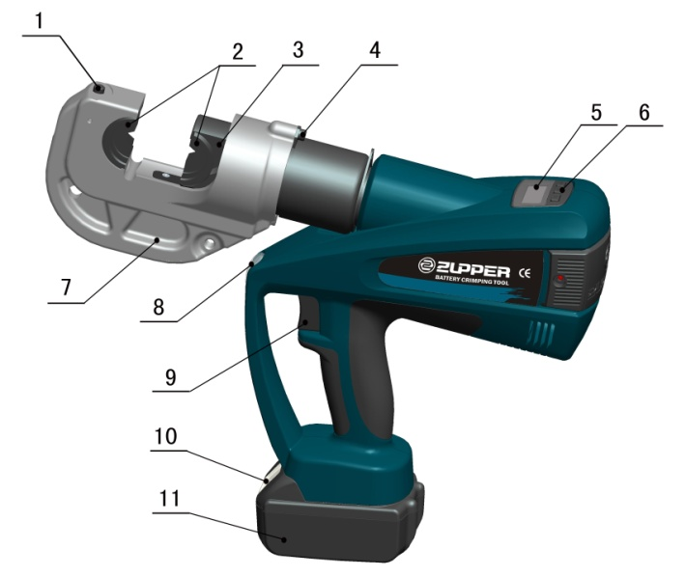
Parts No. | Description | Function
1 | Pin | For fixing die
2 | Die | For crimping, interchangeable die
3 | Retaining clips | For locking/unlocking die.
4 | Limited screw | For preventing head from dropping or popping.
5 | LCD | Showing the data (crimping times, electricity capacity, error information)
6 | Keyboard | For power switch, function switch, LED light switch
7 | Crimping head | C crimping head, for fixing the crimping die
8 | LED indicator | For lighting
9 | Trigger | For operating or retracting the piston in case of incorrect operation.
10 | Lock | Locking the battery
11 | Battery | For supplying power, rechargeable Li-ion（18V）.

Set the output force | Press for 3 s to enter setting status, the data display by flashing. Press the per time, output data increases by 10 KN (or 5 KN, according to requirement), this action is rotated from Min KN to Max KN. Press for 3 s or leave it 15 s, it returns to its initial state.  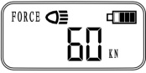
LED set | Convenient in dark enviroments, with a light symbol showing on the LCD, long press button to get into start status. display, and lighting. LCD background lighting, meanwhile press the power button, the front LED lighting, after 20 s, the light turn off automatically. During LED lighting, keep for pressing to turn off the LED even for the LCD background light.  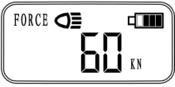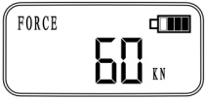
Battery power | full power.  , flashing and buzzing according to the flash  frequency .Do charge the battery in time.
Error showing | Error happened, such as motor damage, drive system error and hydraulic system problem… the tool stopped working. LCD showing “error data” as following: it stands for “over power capacity”  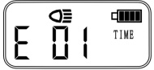
Power off | Press for 3 s or leave the tool 30 mins to turn off the power automatically.
USB pot with computer | Remove battery from the tool, connect the USB with a computer to exchange the data. LCD showing symbol

automatically, so take out the battery from the tool and make sure to charge it one time per quarter.

Usage of the tool
- LCD board instruction:
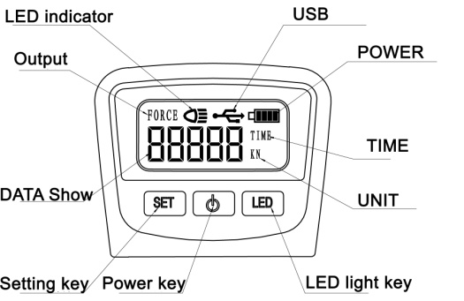
- LCD board showing and setting:
Please note: tool in power off , there is no any data showing.
Power on | Press for 3 s, the tool is in starting status, the keyboard shows all the data for 1 s, then the tool is in the self inspecting mode for 1 s. the data will show last record, the tool is ready for work.  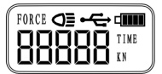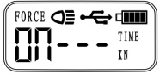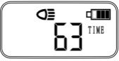
Change the data | In the power on status, press , the data changes  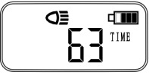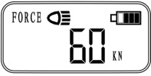

Function description
MCU –automatically detect the pressure during operation and provide Security protect, shut off the motor and reset automatically after
operation.
Auto reset- Release the pressure automatically, retract the piston to the
starting position when reached the max output.
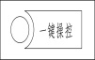
One key control- press the trigger to start working, half releasing the trigger means stop forcing pressure, releasing fully means piston returns to the
original position.
The unit is equipped with a double piston pump which is characterized
by a rapid approach of the die towards the connector and a slow crimping
motion
The head can be smoothly turned by 350° around the longitudinal axis
in order to gain better access to tight corners and other difficult working
areas.
Suspend—finish working or withdraw the hand from the trigger or any accident happened, the device inside of the tool can stop power supply.
One significant sound will be heard and a red display flashes if any error occurs or lower power being.( Ref. table 1)
Per time pressing on the trigger, the LED will lighting for 20 seconds.
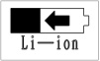
High-performances Li-ion battery in strong power supply, No discharge memory effect., Ultra lower power consumption standby design keep the
tool 6 months storage, meanwhile over discharge device prolong the life span of the battery.
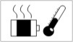
A temperature sensor makes the tool stop working automatically when
the temperature over 60℃ under long time working, the fault signal
sounds, it means the toll can’t continue work until the temperature reduce to the normal.
Micro computer control system with the feature of self-pressure detecting, double protection during operation, counting and realize the exchange
between computer with data by the converter.
Table 1.

Series No | Error code |  | Instruction | What it means
1 | On --- |  | Self-checking | Self-checking to assure everything is ok
2 | E01 |  | Overload | Hydraulic system may  be damaged and need checking immediately
3 |  | ●●● | Charging signal | Lacking power and needs charging.
4 |  | ●—5sec | Power lacking warning | No power and needs charging immediately
5 | E02 |  | Sensor error | Temperature sensor and power inspecting error
6 | E03 | ●●●● | Temperature warning | Temperature too high, tool need to be cooled off
7 | E04 | ●●●●● | No pressure | Motor working but without pressure

OPERATING INSTRUCTION
Read the entire SAFETY INFORMATION section at the beginning of this manual including all text under subheadings therein before using this product.

Use this tool for the manufacturer’s intended purpose only. Use other than that which is described in this manual can result injury or property damage.
1. Charging
Push battery into charger and connect the plug with the plug seat. Make sure the room temperature is between 10C-40C. The charging time is around 2 hours. Please see the illustration below.
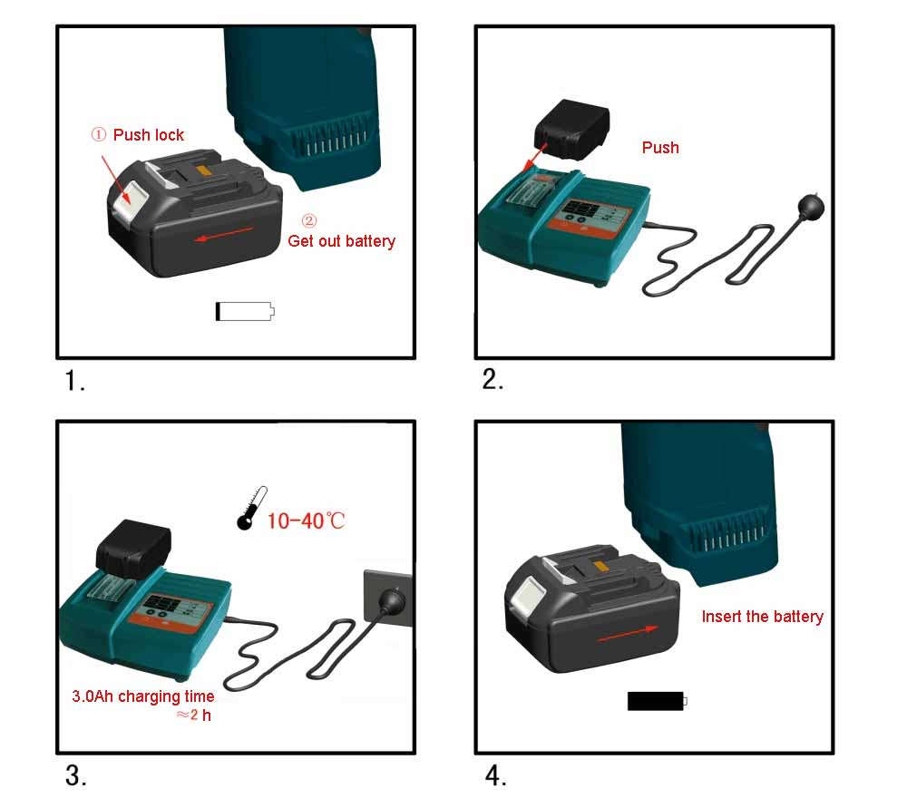
The detail of the charging information, please refer the manual (MANUAL FOR CHARGER)

The battery can be used for hundreds of times, when the life span is reduced, change to a new battery.
Please charging the battery in time to avoid it to be used up absolutely; otherwise it will become useless forever. if the battery not be used for a long time, it will discharge

