

Instruction Manual
Hydraulic Crimping Tool 902-544

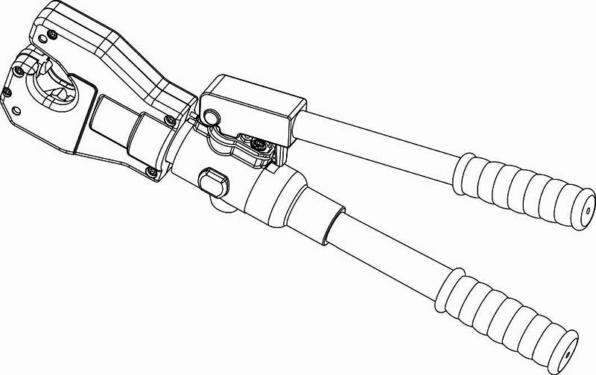

Due to continuing improvements, actual product may differ
slightly from the product described herein.


Read this material before using this product.
Failure to do so can result in serious injury.
SAVE THIS MANUAL

SAVE THIS MANUAL
Keep this manual for the safety warnings and precautions, assembly, operating,
inspection, maintenance and cleaning procedures. Write the month and year of
purchase. Keep this manual and the receipt in a safe and dry place for
future reference.

IMPORTANT SAFETY INFORMATION
In this manual, on the labeling, and all other information
provided with this product:

This is the safety alert symbol. It is used to alert you to potential
personal injury hazards. Obey all safety messages that follow this
symbol to avoid possible injury or death.


DANGER indicates a hazardous situation which,
if not avoided, will result in death or serious injury.


WARNING indicates a hazardous situation which,
if not avoided, could result in death or serious injury.


CAUTION, used with the safety alert symbol,
indicates a hazardous situation which, if not avoided,
could result in minor or moderate injury.

LIMITED 1 YEAR WARRANTY
We make every effort to assure that its products meet high quality and durability standards, and warrants to the original purchaser that this product is free from defects in materials and workmanship for the period of one year from the date of purchase (90 days if used as rental equipment). This warranty does not apply to damage due directly or indirectly, to misuse, abuse, negligence or accidents, repairs or alterations outside our facilities, normal wear and tear, or to lack of maintenance. We shall in no event be liable for death, injuries to persons or property, or for incidental, contingent, special or consequential damages arising from the use of our product. Some states do not allow the exclusion or limitation of incidental or consequential damages, so the above limitation of exclusion may not apply to you. THIS WARRANTY IS EXPRESSLY IN LIEU OF ALL OTHER WARRANTIES, EXPRESS OR IMPLIED, INCLUDING THE WARRANTIES OF MERCHANTABILITY AND FITNESS.

To take advantage of this warranty, the product or part must be returned to us with transportation charges prepaid. Proof of purchase date and an explanation of the complaint must accompany the merchandise. If our inspection verifies the defect, we will either repair or replace the product at our election or we may elect to refund the purchase price if we cannot readily and quickly provide you with a replacement. We will return repaired products at our expense, but if we determine there is no defect, or that the defect resulted from causes not within the scope of our warranty, then you must bear the cost of returning the product.

The warranties give you specific legal rights and you may also have other rights which vary from place to place.

No | Description | Qty | No | Description | Qty
25 | single-direction valve body | 2 | 72 | fixed handle | 1
26 | drum spring | 2 | 73 | protection cover | 1
27 | steel ball C5 | 2 | 74 | fixed handle sleeve | 1
28 | single-direction valve seat | 2 | 75 | O-ring 23.8X3.1 | 1
29 | nylon gasket 9X7X2 | 1 | 76 | O-ring 41X2.5 | 1
30 | spring 0.2X4.8/3.5X10 =-7 | 1 | 77 | steel ball C5.5 | 1
31 | steel ball C4 | 1 | 78 | spring 0.7X4.8X13.2 n=7 | 1
32 | cylinder | 1 | 79 | oil return screw | 1
33 | plastic retainer ring 11X8X1.5 | 1 | 80 | steel ball C5.5 | 1
34 | O-ring 7X2 | 1 | 81 | plunger | 1
35 | O-ring 17X2.5 | 2 | 82 | spring 0.7X4.8X13.2 n=7 | 1
36 | plunger | 1 | 83 | O-ring 3X2 | 1
37 | pin 7X34.5 | 1 | 84 | plastic retainer ring 7X41.2 | 1
38 | retainer ring 6 | 2 | 85 | filter | 1
39 | rubber sleeve | 1 | 86 | clamp | 1
40 | handle stander | 1 | 87 | housing | 1
41 | heavy duty straight pin 3X28 | 1 | 88 | steel ball C5.5 | 1
42 | pin sleeve | 4 | 89 | spring 0.7X4.8X13.2 n=7 | 1
43 | torsional spring | 1 | 90 | O-ring 3X2 | 1
44 | handle head | 1 | 91 | plastic retainer ring 7X41.2 | 1
45 | heavy duty straight pin 3X25 | 1 | 92 | oil plug | 1
46 | active handle | 1 | 93 | heavy duty straight pin 4X30 | 1
47 | handle sleeve | 1

GENERAL SAFETY RULE

TO WORK IN SAFE CONDITIONS WITH THIS TOOL, IT IS IMPERATIVE TO READ CAREFULLY THE DIRECTIONS FOR USE AND TO FOLLOW THE INSTRUCTION IT CONTAINS. IF YOU DO NOT RESPECT THE INFORMATION WRITTEN IN THE INSTRUCTION MANUAL, THE WARRANTY WILL BE CANCELED.

1. Work area safety
  - Keep work area clean and well lit. Cluttered or dark areas invite accidents.
  - Keep children and bystanders away while operating the hydraulic crimping tool Distractions can cause you to lose control.

2. Personal safety
  - Stay alert, watch what you are doing and use common sense when operating the tool. Do not use the tool while you are tired or under the influence of drugs, alcohol or medication.. A moment of inattention while operating hydraulic tools may result in serious personal injury.
  - Use safety equipment. Always wear eye protection. Safety equipment such as dust mask, non-skid shoes, hard hat, or hearing protection used for appropriate conditions will reduced personal injuries.
  - Dress properly. Do not wear loose clothing or jewelry. Keep your hair，clothing and gloves away from moving parts. Loose clothes jewelry or long hair can be caught in moving parts.
  - Do not force the tool. Use the correct power tool for your application .The correct power tool will do the job better and safer at the rate for which it was designed.
  - Store idle power tools out of the reach of children and do not allow persons unfamiliar with the hydraulic crimping tool. This tool is dangerous in the hands of untrained users.
  - Maintain power tools. Check for misalignment or binding of moving parts, breakage of parts and any other condition that may affect the Hydraulic crimping tool operation. If damaged, have the Hydraulic crimping tool repaired before use. Many accidents are caused by poorly maintained power tools.
  - Use the Hydraulic Crimping Tool, accessories and tool bits etc., in accordance with these instructions and in the manner intended for the particular type of tool, taking into account the working conditions and the work to be performed. Use of the Hydraulic Crimping tool for operations different from those intended could result in a hazardous situation.

3. Service
Have your Hydraulic Crimping Tool serviced by a qualified service technician using only identical replacement parts. This will ensure that the safety of the Hydraulic Crimping Tool Kit is maintained.

No | Description | Qty | No | Description | Qty
1 | hexagon scrtew M5×30 | 2 | 48 | pressure release pin | 1
2 | hexagon scrtew M6×30 | 3 | 49 | pin 7X29.5 | 1
3 | housing B | 1 | 50 | O-ring 8X1.5 | 1
4 | die | 1 | 51 | pressure adjusting screw M8X9 | 1
5 | guide block | 1 | 52 | safety valve body | 1
6 | retract spring 1X7.8X50 n=15 | 2 | 53 | spring 1.2X4.5X22 n=15 | 1
7 | moveable die | 2 | 54 | O-ring 2.2X1.9 | 1
8 | roller pin P 5X11.8 | 10 | 55 | valve spindle | 1
9 | holder | 2 | 56 | safety valve seat | 1
10 | guide sleeve | 2 | 57 | nylon gasket 11X9X2 | 1
11 | guide pin | 2 | 58 | oil return screw plug | 1
12 | housing A | 1 | 59 | oil return cartridge | 1
13 | limited pin 4X17 | 2 | 60 | O-ring 2.2X1.9 | 1
14 | die holder | 1 | 61 | spring 0.7X4.8X13.2 n=7 | 1
15 | hexagon screw M4X6 | 2 | 62 | inner hexagon srew M5X5 | 1
16 | gasket 24 | 1 | 63 | steel ball C4 | 1
17 | plastic retainer ring 11X8X1.5 | 1 | 64 | inner hexagon set screw M5X5 | 1
18 | O-ring 7X2 | 1 | 65 | filter | 1
19 | piston screw | 1 | 66 | filter sieve | 1
20 | piston | 1 | 67 | plastic retainer ring | 1
21 | spring nut | 2 | 68 | oil tube | 1
22 | retract spring | 1 | 69 | plug | 1
23 | plastic retainer ring 40X35X1.3 | 1 | 70 | fixed handle head | 1
24 | O-ring 33X3.5 | 1 | 71 | heavy duty straight pin 3X5 | 2
Parts list
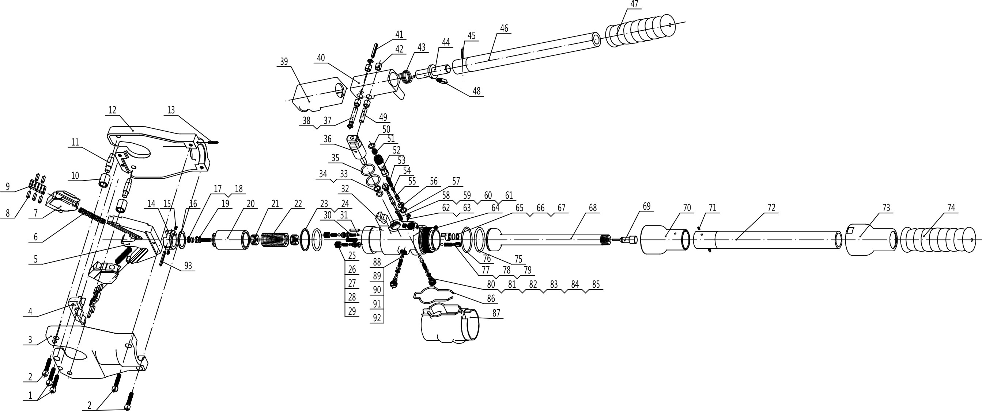

SPECIFIC SAFETY RULES
- Maintain labels and nameplates on the tool which carry important safety information. If unreadable or missing, contact the agent to replace.
- This product is not a toy, keep it out of reach of children.
- Do not slide your fingers in the dies profile.
- Do not crimp on live cables or conductors
- Do only crimp copper or aluminum conducting material
- The warnings, precautions, and instructions discussed in this instruction manual cannot cover all possible conditions and situations that may occur. It must be understood by the operator that common sense and caution are factors which cannot be built into this product, but must be supplied by the operator.


SAVE THESE INSTRUCTIONS

UNDERSTAND YOUR TOOL
902-544 is a non-interchangeable crimping tool, suitable for crimping tubular cable lugs and connectors, standard type and tubular cable lugs. It has many advantages of two stage hydraulics, the head can be rotated 360 degrees. It doesn’t require changing the die, it has three movable dies pushing connectors against the top fixed die to finish crimping.

1. Specification
Crimping force: | 6 Ton
Crimping range: | Cu AWG 8 to 450 MCM
Stroke: | 1.38 inch
Oil capacity: | 60cc
Oil | T 15#
Ambient temperature: | -20℃～40℃
Weight: | 11 lbs
Package: | Plastic box

2. Description of the components.
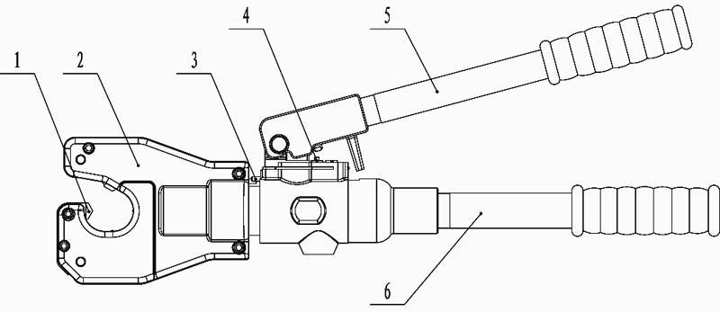

TROUBLESHOOTING
FAULT | ANALYSIS | SOLUTION
A. No pressure or the pressure is not enough during operation | - The pump lacks oil  - There is dust in oil  - Inner leakage | - Fill the oil  - Change the oil  - Contact manufacturer or distributor
B. The connector and cable do not connect tightly after crimping. | - The tool can not reach to the rated pressure | - Refer to the fault A
C. Oil leakage on the head or on the plunger | 1. Sealing kit is broken | 1. Contact manufacturer or distributor and replace it by trained person

PLEASE READ THE FOLLOWING CAREFULLY
THE MANUFACTURER AND/OR DISTRIBUTOR HAS PROVIDED THE PARTS LIST AND ASSEMBLY DIAGRAM IN THIS MANUAL AS A REFERENCE TOOL ONLY. NEITHER THE MANUFACTURER NOR DISTRIBUTOR MAKES ANY REPRESENTATION OR WARRANTY OF ANY KIND TO THE BUYER THAT HE OR SHE IS QUALIFIED TO MAKE ANY REPAIRS TO THE PRODUCT, OR THAT HE OR SHE IS QUALIFIED TO REPLACE ANY PARTS OF THE PRODUCT. IN FACT, THE MANUFACTURER AND/OR DISTRIBUTOR EXPRESSLY STATES THAT ALL REPAIRS AND PARTS REPLACEMENTS SHOULD BE UNDERTAKEN BY CERTIFIED AND LICENSED TECHNICIANS, AND NOT BY THE BUYER. THE BUYER ASSUMES ALL RISK AND LIABILITY ARISING OUT OF HIS OR HER REPAIRS TO THE ORIGINAL PRODUCT OR REPLACEMENT PARTS THERETO, OR ARISING OUT OF HIS OR HER INSTALLATION OF REPLACEMENT PARTS THERETO.

MAINTENANCE AND SERVICING
Damaged equipment can fail, causing serious personal injury. Do not use damaged equipment. If abnormal noise or vibration occurs, have the problem corrected before further use.

- BEFORE EACH USE, inspect the general condition of the tool. Check for loose screws, misalignment or binding of moving parts, cracked or broken parts, and any other condition that may affect its safe operation.
- AFTER USE, depress the release lever to activate the piston to the end, clean surface of the tool with a clean, moist rag and smear rust preventing oil on the metal surfaces of the tool and the dies to avoid rust. Store the tool in the dry environment.
- Service to the tool should only be done by a qualified Service Technician.
- In order to prolong the life of the tool please change the oil once per year. Make sure the oil is filtered by 120 mesh net or over 30µm strainer. Meantime avoid getting dust into the oil cup.

How to change oil:

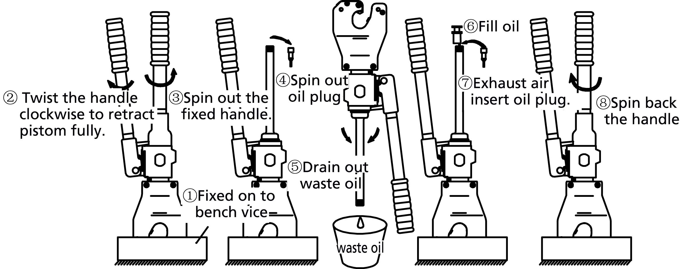

Code | Name | Function
1 | Die | for crimping, unchangeable crimping die
2 | Head | for holding die
3 | Limited pin | for preventing head from excessive rotating
4 | Release valve | for releasing pressure and retracting the die and piston back to starting position.
5 | Active handle | for operating
6 | Fixed handle | for storing oil

3. Function description
- 360° rotating head enlarges application range.
- Two stage pumping actions for rapid advancing to the connector with minimum pumping action.
- The pressure release valve can retract the die and piston quickly to their starting positions during or after crimping.
- The built-in safety valve can measure precise pressure during crimping so to prevent operator from dangerous.

The built-in safety valve is tested before shipment, the user can not adjust by yourself, please send the tool to the professional trained person to adjust, then use the tool.

OPERATING INSTRUCTIONS.
Read the ENTIRE IMPORTANT SAFETY INFORMATION section at the beginning of this manual including all text under subheadings therein before set up or use of this product.

Please do not knock any parts of the tool, otherwise it is dangerous for the operator.

Do not put your fingers into the head of the tool during operating. Your fingers could be pinched very severely.

- Retract the die and piston back to starting position by twisting handle clockwise. Make sure the tool is under its original situation before operating.
- Insert cable fully into connector and then center it between dies.
- Pumping the handle, the three moveable dies will move toward and hold the connector automatically. Be sure the connector was centered between dies. Keep pumping until a significant sound was heard, it means we have finished one cycle of crimping.
- Press the active handle a little bit, twist the handle clockwise to release the pressure, retract the die and piston.
- Take out cable when the die and piston retracted fully.

Please refer to the illustration below.

